WEEK – 3 SIMULATIONS OF CAMPAIGN OPTIMIZATION STRATEGIES

INTRODUCTION: -
The following report offers a simulation study that aims at assessing marketing optimization strategies through various variables. These variables include budget distribution, marketing channels, and target customers. This study helps understand the effects of such modifications on different performance measures such as profits, number of transactions, and return on investment.

2. OBJECTIVE:-
- To simulate different marketing strategies.
- To evaluate impact on KPIs (CTR, Conversion Rate, ROI and Revenue)
- To recommend optimal campaign strategies.

4. DATASET:-
The dataset includes:
- KPIs such as Impressions, Clicks, Conversions and Cost.
- Product spending data
- Campaign response variables.
- Channel purchase data (Web, Store, Catalog)

4. METHODOLOGY:-
The simulation model has been constructed using Excel / PowerBI with DAX measures. Various scenarios have been developed through changing parameters like budget allocation, channel mix, and focus on campaigns.
2. VARIABLES USED:-
1. Budget Allocation
2. Channel Mix (Web, Store, Catalog)
3. Campaign Focus
4. Conversion Rate Assumption

5. DEVELOPMENT OF HYPOTHESIS:-
Following Hypotheses were tested.
1. Increase in budget for high performing campaigns will improve ROI
2. Optimal channel mix strategy in favor of high performing channels will boost conversions
3. Improvement in CTR will increase revenues

6. SIMULATION MODEL DESIGN:-
1. BASE SCENARIO:- Represents current performance metrics without changes.

2. SCENARIO 1: Increase Budget Allocation:-
1. Increase the budget by 20% for top campaign
2. Measure the change in ROI and Revenue.

3. SCENARIO 2: Improved CTR:-
1. Improved CTR by 10%
2. Noted the increase in Conversions and Revenue.

4. SCENARIO 3: Channel Optimization:-
1. Shift 15% budget to best-performing Channel i.e. Store.
2. Notice the change in conversions.

5. COMBINED STRATEGY:-
Budget increase + CTR improvement + Channel optimization

EXPLAINATION IN DETAIL FOR ALL SCENARIO’s:-
BASE CASE: - We have the data without any modifications.
Conversions:- 334
Cost: - 18300
CTR: - 0.768%
Impressions: - 1190900
Clicks: - 9150
Conversion Rate: - 3.65%
Revenue: - 1356988
ROI: - 73.15
Image – 1 (BASE CASE)
CALCULATIONS: -
1. CTR Check:-
CTR = Clicks / Impressions
= 9150 / 1190900 ≈ 0.00768 = 0.768%
2. CONVERSIONS:-
Conversions = Clicks × Conversion Rate
= 9150 × 3.65% ≈ 334
3. ROI(Return On Investment):-
ROI = (Revenue - Cost) / Cost
= (1,356,988 - 18,300) / 18,300 ≈ 73.15
The base scenario represents the current performance of marketing campaigns and serves as a benchmark for evaluating the impact of simulated optimization strategies.

SCENARIO – 1 Increase Budget Allocation: -
If there is increase in the budget then it will lead to increase in Impressions also
Impressions Increases -> Then it will also increase the Clicks if Clicks increases then it will lead in increase of conversions hence More Revenue generated.
INITIALLY:-
After Increment of Budget by 20%
CTR and Conversion Rate remains same
Conversions = 401
Cost: - 18300*1.2 = 21960
CTR: - 0.768%
Impressions: - 1190900*1.2 = 1429080
Clicks: - 10980
Conversion Rate: - 3.65%
Revenue: - 1628386
ROI: - 73.15
CALCULATIONS:-
1. NEW COST: - 18300* 1.2 = 21960
2. NEW IMPRESSIONS:- 1190900*1.2 = 1429080
3. NEW CLICKS:- CTR*Impressions = 0.768*1429080 = 10980
4. NEW CONVERSION:- Clicks*Conversion Rate = 10980*3.65 = 401
5. NEW REVENUE:- (Base Revenue) * (New conversions/base Conversions)
= 1356988 * (401/334) = 1628386
6. NEW ROI:- (New Revenue – Cost)/Cost = (1628386-21960)/21960 = 73.15
Image – 2 (SCENARIO – 1 Budget Increment)
Increasing the budget results in higher impressions, which leads to more clicks and conversions. However, ROI remains relatively stable because both cost and revenue increase proportionally.

SCENARIO – 2 Improved CTR: -
If there is increment in the CTR then it will lead to increase in the number of Clicks if the Clicks will increase Then it will Increase the conversions So more Revenue will be generated.
INITIALLY:-
After Improved CTR by 10% Then
Cost, Impressions and Conversion Rate remains same
Conversions = 367
Cost: - 18300
CTR: - 0.845%
Impressions: - 1190900
Clicks: - 10065
Conversion Rate: - 3.65%
Revenue: - 1492687
ROI: - 80.57
CALCULATIONS:-
1. NEW CTR: - 0.768% * 1.1 = 0.845%
2. NEW CLICKS:- CTR*Impressions = 0.845*1190900 = 10065
4. NEW CONVERSION:- Clicks*Conversion Rate = 10065*3.65% = 367
5. NEW REVENUE:- (Base Revenue) * (New conversions/base Conversions)
= 1356988 * (367/334) = 1492687
6. NEW ROI:- (New Revenue – Cost)/Cost = (1492687-18300)/18300 = 80.57
Image – 3(SCENARIO – 2 Improved CTR)
Increasing CTR improves user engagement, leading to higher clicks and conversions, which ultimately increases revenue and ROI without increasing cost.

SCENARIO – 3 Channel Optimization: -
If there is increment in the Conversion Rate then it will lead to increase in the number of Conversions So more Revenue will be generated.
INITIALLY:-
After Increment of Conversion rate by 15% Then
Cost, CTR and Impressions remains the same
Conversions: - 384
Cost: - 18300
CTR: - 0.768%
Impressions: - 1190900
Clicks: - 9150
Conversion Rate: - 4.20%
Revenue: - 1560536
ROI: - 84.28
CALCULATIONS:-
1. NEW CONVERSION RATE: - 3.65%*1.15 = 4.20%
4. NEW CONVERSION:- Clicks*Conversion Rate = 9150*4.20% = 384
5. NEW REVENUE:- (Base Revenue) * (New conversions/base Conversions)
= 1356988 * (384/334) = 1560536
6. NEW ROI:- (New Revenue – Cost)/Cost = (1560536-18300)/18300 = 84.28
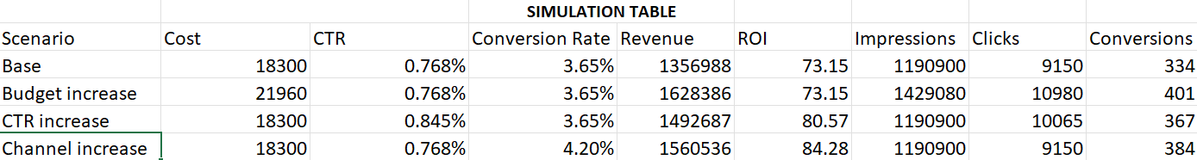
Image – 3 (SCENARIO – 3 Channel Optimization)
Improving conversion rate significantly increases revenue and ROI, as more users complete the desired action without increasing marketing cost.

SCENARIO – 4 COMBINED STRATEGY: -
Budget(20%) + CTR (10%) + Conversion Rate (15%)
It is the combination of all three scenarios Budget increment + Improved CTR + Conversion Rate increment
INITIALLY:-
After the increment of all three it will be displayed as:-
Conversions:- 507
Cost: - 21960
CTR: - 0.845%
Impressions: - 1429080
Clicks: - 12078
Conversion Rate: - 4.20%
Revenue: - 2059908
ROI: - 92.80

CALCULATIONS:-
1. NEW COST: - 18300* 1.2 = 21960
2. NEW CTR:- 0.768*1.1 = 0.845%
3. NEW IMPRESSIONS:- 1190900*1.2 = 1429080
4. NEW CLICKS:- CTR*Impressions = 0.845*1429080 = 12078
5. NEW CONVERSION RATE:- 3.65%*1.15 = 4.20%
6. NEW CONVERSION:- Clicks*Conversion Rate = 12078*4.20 = 507
7. NEW REVENUE:- (Base Revenue) * (New conversions/base Conversions)
= 1356988 * (507/334) = 2059908
8. NEW ROI:- (New Revenue – Cost)/Cost = (2059908-21960)/21960 = 92.80
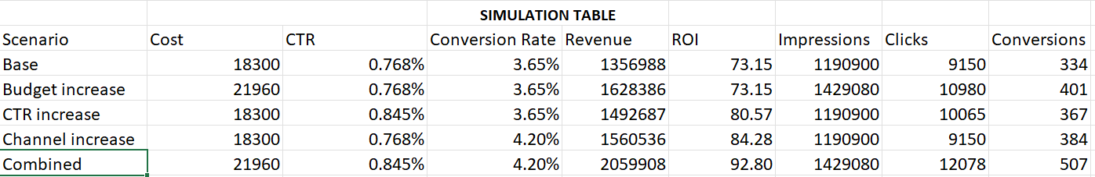
Image – 4 (Combined Strategy)
The combined optimization strategy results in the highest increase in revenue and ROI, as it simultaneously improves reach, engagement, and conversion efficiency.

VISUALIZATION BY CHARTS:-
1. REVENUE COMPARISON:-
Helps us to understand which scenario performs best?
By Stacked Bar chart:-
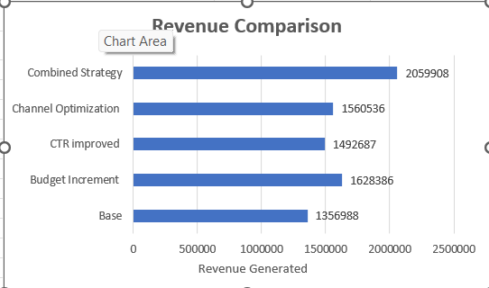
Image – 5 (Revenue Comparison)
Insights:- The combined scenario leads to the highest Revenue, indicating multiple optimizations leads to max performance.

2. ROI COMPARISON:-
Identify most profitable strategy?
Clustered Column Chart:-
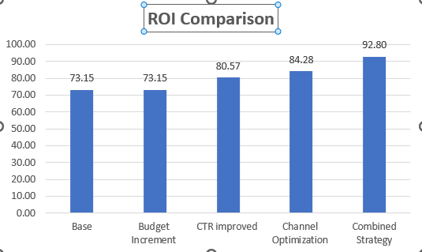
Image – 6 (ROI Comparison)
Insights:- Conversion improvement provides the highest ROI since it increases revenue without increasing cost.

3. CONVERSION COMPARISON:-
Show which scenario generates most customers?
Clustered Bar Chart
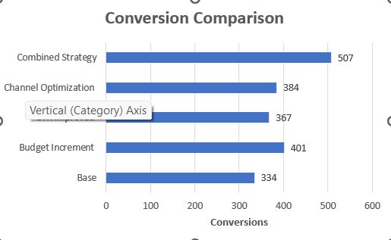
Image – 7 (Conversion Comparison)
Insights:- Combined strategy yields the highest number of conversions due to improvements at all stages of the funnel.

4. FUNNEL CHART:-
Impressions -> Clicks -> Conversions
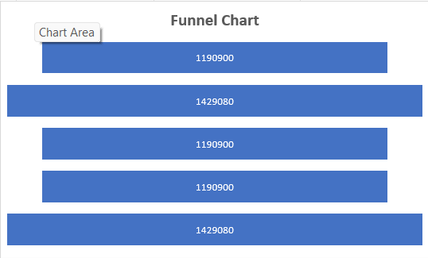
Image – 8 (Funnel Chart)
Insights:- There is a significant drop between impressions and clicks, indicating low engagement.
KEY LEARNINGS:-
1. Allocation of budget is critical for driving revenue
2. Optimization of channels enhances conversion rate
3. Small changes in CTR will have a significant impact downstream

RECOMMENDATIONS:-
1. Increase budget allocation in successful campaigns
2. Pay attention to successful channels (Store/Web)
3. Develop ad content to boost CTR

CONCLUSION:-
Simulation helps show that effective management and optimization of marketing parameters can have a positive impact on campaign effectiveness. The most successful approach is to optimize budget, channel management, and click-through rate.

